SQL questions:

Question 1

Query the list of CITY names starting with vowels (i.e., a, e, i, o, or u) from **STATION**. Your result cannot contain duplicates.

Sol:

^ denoted the starting of the string

Ques 2:

Query the list of CITY names ending with vowels (a, e, i, o, u) from **STATION**. Your result cannot contain duplicates.

SOL: $ indicates the end of the string

Ques 3:

Query the list of CITY names from **STATION** which have vowels (i.e., a, e, i, o, and u) as both their first and last characters. Your result cannot contain duplicates.

Sol:-

Ques 4:

Query the list of CITY names from **STATION** that do not start with vowels. Your result cannot contain duplicates.

Sol:-

Ques 5:

Query the list of CITY names from **STATION** that do not end with vowels. Your result cannot contain duplicates.

SOL:-

Ques 6: -

Query the list of CITY names from **STATION** that either do not start with vowels or do not end with vowels. Your result cannot contain duplicates

Sol:-

Ques 7:

Query the list of CITY names from **STATION** that do not start with vowels and do not end with vowels. Your result cannot contain duplicates.

Sol;

Ques 8:

Query the Name of any student in **STUDENTS** who scored higher than  Marks. Order your output by the last three characters of each name. If two or more students both have names ending in the same last three characters (i.e.: Bobby, Robby, etc.), secondary sort them by ascending ID.

Sol:

Ques 9:-

Given the **CITY** and **COUNTRY** tables, query the names of all cities where the CONTINENT is 'Africa'.

**Note:** CITY.CountryCode and COUNTRY.Code are matching key columns.

Sol:-

Ques 10:-

Write a query identifying the *type* of each record in the **TRIANGLES** table using its three side lengths. Output one of the following statements for each record in the table:

* **Equilateral**: It's a triangle with  sides of equal length.
* **Isosceles**: It's a triangle with  sides of equal length.
* **Scalene**: It's a triangle with  sides of differing lengths.
* **Not A Triangle**: The given values of *A*, *B*, and *C* don't form a triangle.

Ques 11:

Generate the following two result sets:

1. Query an *alphabetically ordered* list of all names in **OCCUPATIONS**, immediately followed by the first letter of each profession as a parenthetical (i.e.: enclosed in parentheses). For example: AnActorName(A), ADoctorName(D), AProfessorName(P), and ASingerName(S).
2. Query the number of ocurrences of each occupation in **OCCUPATIONS**. Sort the occurrences in *ascending order*, and output them in the following format:
3. There are a total of [occupation_count] [occupation]s.

where [occupation_count] is the number of occurrences of an occupation in **OCCUPATIONS** and [occupation] is the *lowercase* occupation name. If more than one *Occupation* has the same [occupation_count], they should be ordered alphabetically.

Ques 12:

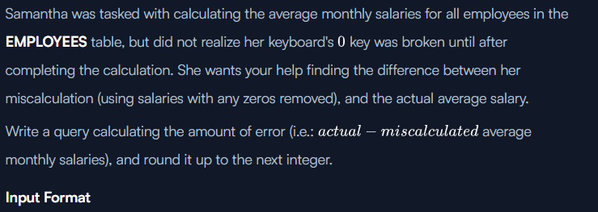

Sol:-

Ques13:

SOL:-

Ques 14:

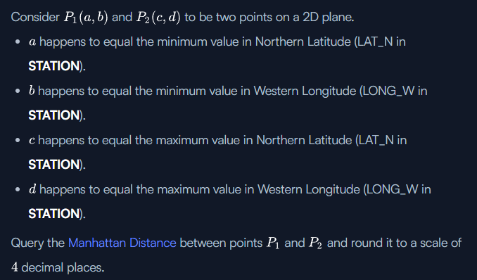

Sol:-



QUES 15:

SOL:



Question 16:

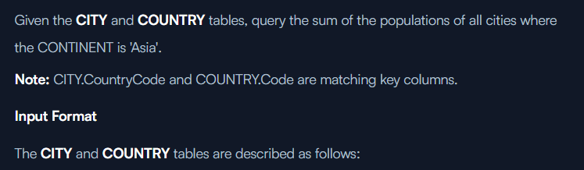

Sol:

Ques 17:

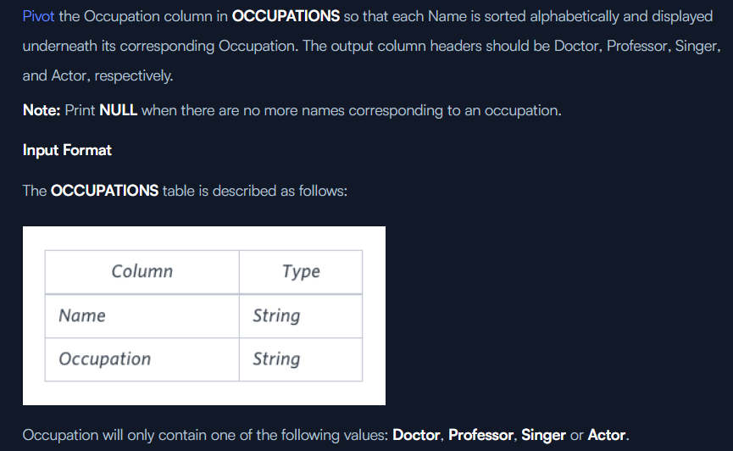

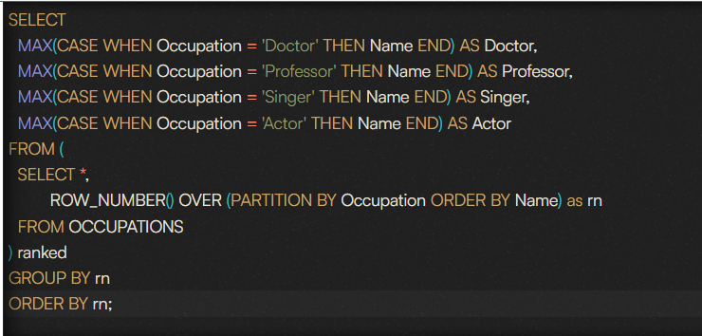

https://medium.com/@datasciencenexus/20-medium-level-sql-interview-questions-and-answers-de0270cc3078